**Development of a traffic police assistant system called Bi-QR based on Mobile platforms.**

**Abu Fahim Khan Shantanu**

**ID: 2019-1-60-048**

**Raisur Rahman**

**ID: 2019-1-60-180**

**Md. Mahmud Hassan Akhonda**

**ID: 2019-1-60-193**

**Anik Saha**

**ID: 2019-1-60-220**

**A Capstone project report submitted in partial fulfillment of the requirements for the degree of Bachelor of Science in Computer Science and Engineering.**



**Department of Computer Science & Engineering,**

**East West University.**

**Dhaka-1212, Bangladesh.**

**November, 2023**

# **Declaration**

We, **Anik Saha, Abu Fahim Khan Shantanu, Md. Mahmud Hassan Akhonda and Raisur Rahman.** hereby, declare that the work presented in this capstone project report is the outcome of the investigation performed by us under the supervision of **MD. Mahir Ashhab,** Lecturer, Department of Computer Science and Engineering, East West University. We also declare that no part of this project has been or is being submitted elsewhere for the award of any degree or diploma, except for publication.

Countersigned Signature

…………………….. ……………………..

**MD. Mahir Ashhab Anik Saha**

**(Supervisor) 2019-1-60-220**

Signature

……………………..

**Abu Fahim Khan Shantanu**

**2019-1-60-048**

Signature

……………………..

**Md. Mahmud Hassan Akhonda**

**2019-1-60-193**

Signature

……………………..

**Raisur Rahman**

**2019-1-60-180**

# **Letter Of Acceptance**

The capstone project report entitled **"Development of a traffic police assistant system called Bi-QR based on Mobile platforms."** is submitted. By **Anik Saha, Abu Fahim Khan Shantanu, Md. Mahmud Hassan Akhonda and Raisur Rahman.** to the Department of Computer Science and Engineering, East West University, Dhaka, Bangladesh is accepted for the partial fulfillment of the requirement for the degree of Bachelor of Science in Computer Science and Engineering on (07 November 2023).

Board of Examiners

1.

MD. Mahir Ashhab, (Supervisor)

Lecturer,

Department of Computer Science and Engineering

East West University.

2.

Dr.Maheen Islam, (Chairperson)

Associate Professor ,

Department of Computer Science and Engineering

East West University.

# 

# **Abstract**

This research paper presents the comprehensive development and implementation of BIQR, an innovative mobile application designed to transform the landscape of law enforcement document verification processes. The BIQR mobile app was carefully developed to meet the urgent demand for increased security, efficiency, and accuracy in law enforcement agencies. It does this by utilizing real-time database integration and state-of-the-art Optical Character Recognition (OCR) technology.

This paper explores the complex technological architecture and design ideas that support the BIQR mobile application. The OCR algorithms were carefully honed, user interface experiences were optimized, and smooth connectivity with law enforcement databases was guaranteed.

The BIQR mobile app has developed into a powerful tool capable of automating the verification of driver documents, car registrations, insurance papers, and other documents via rigorous testing and iterative development.Hence minimizing mistakes and significantly reducing the amount of human labor.An extensive examination of the app's effects on law enforcement activities is included in this report. Case studies from the real world and user comments demonstrate the useful applications of BIQR, emphasizing how it may improve traffic safety, law enforcement effectiveness, and compliance with regulations.

The report also addresses the difficulties encountered when developing the app, including the tactics used to go above these barriers and improve the software.This study paper offers insightful information about the transformative potential of technology in the field of law enforcement, in addition to showcasing the technical expertise involved in producing the BIQR mobile app. This study adds crucial knowledge to the subject of law enforcement technology by giving a thorough explanation of the development process, difficulties encountered, and results attained.

The BIQR smartphone app is proof of the ability of creativity to address pressing social issues and opens the door to a law enforcement environment that is safer, more effective, more technologically sophisticated.

**Acknowledgment:**

We would like to express our deepest gratitude to all those who contributed to the development and implementation of the BIQR mobile application, transforming it into a groundbreaking tool for law enforcement document verification.

This project would not have been possible without the dedicated efforts of a diverse and talented team.

First and foremost, we extend our sincere appreciation to the developers and engineers who tirelessly worked on the intricate technological architecture and design of the BIQR mobile app. Their expertise and commitment to excellence have resulted in a sophisticated application that addresses the critical needs of law enforcement agencies.

The success of BIQR is also attributed to the individuals who meticulously honed the Optical Character Recognition (OCR) algorithms, ensuring the highest level of accuracy in document verification. Their innovative contributions have significantly enhanced the app's capabilities and effectiveness.

We are grateful for the collaboration with law enforcement agencies that provided valuable insights and feedback throughout the development process. Their practical knowledge and real-world perspectives were instrumental in refining BIQR into a practical and efficient tool for enhancing security and compliance.

This research paper benefited greatly from the dedication of our testing and quality assurance teams. Their rigorous examination of the app's functionalities played a crucial role in minimizing errors and optimizing the user interface, contributing to the overall success of BIQR.

Lastly, we express our appreciation to all stakeholders, including users who provided feedback and participated in case studies. Your engagement has been essential in demonstrating the real-world impact and applications of BIQR in improving traffic safety, law enforcement effectiveness, and regulatory compliance.

In conclusion, the development of the BIQR mobile app stands as a testament to the collaborative efforts, technical expertise, and innovative spirit of everyone involved. This project has not only addressed urgent societal needs but has also opened new possibilities for a safer and technologically advanced law enforcement environment.

Thank you to each individual and team member who contributed to the success of the

BIQR mobile application.

East West university

**List of Contents**

**Declaration 2**

**Letter Of Acceptance 3**

**Abstract 4**

**Acknowledgement 5**

**Chapter 1**

**1.0 Introduction** **9**

**1.1 Background 10**

**1.2 Motivation 10**

**1.3 Problem Statement and Analysis 11**

**1.4 Project Objectives 12**

**1.5 Business Plan 13**

**1.6 Project Contributors 15**

**Chapter 2 16**

**2.0 Related Works 16**

**2.2 Research Questions** **17**

**Chapter 3 24**

**3.0 Methodology 24**

**3.1 Requirement Engineering 25**

**3.2 UML Use Case Diagram 26**

**3.3 Activity Diagram 27**

**3.4 Sequence Diagram 28**

**3.5Front End Design 39**

**3.6 Back End Design 40**

**3.7 Website Deployment 41**

**3.8 Mobile Application 42**

**Chapter 4 44**

**4.1 Challenges 44**

**4.2 Result 45**

**Chapter 5 48**

**5.1 Conclusion 48**

**5.2 Overall Contribution 49**

**5.3 Future Work and Limitations 50**

**Bibliography 52**

**Appendix 54**

**Mapping of Course and Program Outcomes 54**

**CSE 400 A 54**

**CSE 400 B 57**

**CSE 400 C 62**

# **Chapter 1**

## 1.0 Introduction

The number of motorbikes on roads of Dhaka has substantially increased in recent years. This promotes more traffic congestion and raises safety issues. By 2021, the Bangladesh Road Transport Authority (BRTA) expects that there will be about 2.98 million motorcycles that are registered in Dhaka [9]. This represents a large proportion of all the vehicles in the city and emphasizes the necessity of effective traffic management. As the number of bikes has expanded, Dhaka's infrastructure and facilities for road safety have not kept up, which has resulted in a high number of accidents. This is because paper documents can be replicated and, in some cases, vehicle users who are not eligible for driving licenses. Also in some cases, border crossing vehicles, which don’t have any authorization by any companies and BRTA may have fake papers. This occurs because of brokers who make forged documents in exchange for money. This is a very common affair in Dhaka city. The government has made efforts to address these problems in recent years, including building new rules and enhancing those that already exist, but there's still a lot to be done. The enormous number of motorcyclists in Dhaka offers the city both opportunities and disadvantages. The government and local authorities should prioritize enhancing the road system and assuring motorcyclists safety. Maintaining the traffic system more efficiently, less paperwork, time saving methods, and hassle-free driving that is sustained longer. Using a simple user interface for reducing new hardware uses for paper verification and payments for different cases will make the whole process more efficient to verify the traffic. But there are too many drawbacks to the verification process. First off, because traffic movement is slowed while the verification process is being conducted, it may result in delays and congestion on the highways, leaving passengers and drivers frustrated and stressed. Corruption and authority abuses are other drawbacks. This could erode public confidence in the police force and create an atmosphere of mistrust and dissatisfaction among the public. Additionally, there is a chance that false or forged licenses could still evade detection, making on-road verification ineffective for ensuring the authenticity of driver's licenses. Moreover, manual verification procedures may take a long time and be prone to mistakes, resulting in inaccurate or inconsistent results. In conclusion, it is crucial to think about the potential drawbacks and restrictions of this strategy and look for alternate options that are more effective, efficient, and fair.

## 1.1 Background

Dhaka, the vibrant heart of Bangladesh, faces the challenges typical of a bustling metropolis, among which is the efficient verification of motorcyclists' documents. In this urban landscape, law enforcement agencies are tasked with the responsibility of ensuring that every motorcyclist complies with the necessary legal requirements, from valid licenses to updated registrations and insurance documents. However, the traditional paper-based verification methods have proven to be inadequate for the pace and complexity of urban life. Traffic sergeants, pivotal in maintaining order on the city's roads, find themselves entangled in a time-consuming process of manual document verification, often leading to delays, errors, and potential security risks.

Recognizing the urgency of modernizing this process, the BIQR project emerges as a beacon of innovation. In the era of mobile technology, the opportunity to transform the way document verification occurs is ripe. BIQR not only addresses the immediate need for swift and accurate document checks but also aligns with the broader vision of creating a technologically advanced, digitally connected urban environment. By seamlessly integrating real-time updates and centralizing verification data within a mobile app, BIQR not only offers a solution to a pressing problem but also paves the way for a future where law enforcement in Dhaka is characterized by efficiency, accuracy, and enhanced public safety. This project stands at the intersection of tradition and innovation, redefining the way urban law enforcement operates in the modern age.

## 1.2 Motivation

We are all aware of the value of time in the current world. Yet, due to the numerous traffic checks that motorcyclists have to go through some unwanted situations while riding a bike, it is extremely challenging for motorcycle riders in Dhaka to complete their duties on time. Occasionally, a motorcycle rider must stop for a traffic check more than three times each day, which takes at least 30 to 40 minutes and even more. Moreover, residents in Dhaka who own motorcycles deal with several issues on a regular basis. The capital of Bangladesh, Dhaka, is renowned for its jam-packed streets and frequent traffic mishaps. Due to a large number of vehicles and a lack of infrastructure for traffic management, there are frequent delays, financial losses, and concerns for public safety. The creation of a system for traffic aides that may help with traffic management and enforce adherence to traffic regulations is one potential remedy for these problems. The suggested technology, known as Bi-QR, is a mobile platform that uses QR codes to check required paperwork from motorcycle riders online. The method intends to enhance traffic management by lowering the number of manual inspections necessary and enabling real-time monitoring of traffic offenses by utilizing the prevalence of smartphones and the strength of QR codes. This application's primary goal is to speed up the process of examining motorcycle riders' documentation in the city of Dhaka so that both riders and traffic cops may utilize their time as efficiently as possible. Reduce the regular checking system's use of paper and human mistakes as well. In the metropolitan area of Dhaka, motorcycle riders frequently run into problems. They must always have the paperwork and registration for their motorcycles with them, which can be challenging in inclement weather. The traffic police occasionally halt a large number of motorcycles at the same time at the traffic checkpoint for inspection. where the traffic cops return the documents to the incorrect people and cause a confrontation. In terms of motorbike inspection, there is no set protocol. As a result, there are numerous instances in which both traffic officers and motorcycle riders must deal with challenging circumstances. The traffic police do not properly get enough time in order to inspect all the motorcyclists' papers in person. In addition, many motorcycle riders who carried their paperwork with them at all times have misplaced it. When the motorbike documents are checked there occurs some common mistakes in the checking procedure. Keeping such issues in mind we think of our mobile-based program called Bi-QR. In order for a biker to travel securely in Dhaka city, Bi-Qr offers a motorcyclist portfolio in the system. Several user interfaces contained inside the same software, assist the metropolitan traffic police in their duties as well. This smartphone software creates a special QR code for each user that can be used for verification purposes and aids traffic officers in quickly accessing a biker's profile and reviewing any documentation. A timestamp on Bi-QR lets users know when their profile was last checked, which helps traffic police confirm that a motorcyclist's documents are legitimate. A user's portfolio displays a red flag in their profile if there are any problems with their papers, indicating that they either didn't follow the guidelines or were penalized for their work. The suggested technology, known as Bi-QR, is a mobile platform that uses QR codes to check required paperwork from motorcycle riders online. In our proposed method we will try to enhance traffic management by minimizing congestion by utilizing the widespread use of smartphones and the strength of QR codes. The introduction of this technology has the potential to increase both road safety and law enforcement organizations' general effectiveness. The Bi-QR method may also help to make driving more streamlined and convenient by lowering the time and effort needed for manual documents inspection.

## 1.3 Problem Statement and Analysis

In the bustling urban landscape of Dhaka, efficient verification of motorcyclists' documents stands as a significant challenge for law enforcement agencies. The traditional paper-based verification methods are not only time-consuming but also prone to inaccuracies, leading to potential legal and security risks. Traffic sergeants, burdened by the manual verification process, often struggle to keep up with the rapid pace of urban life, which requires swift, accurate, and real-time document checks. Furthermore, the lack of a centralized system to update the verification status creates loopholes, allowing individuals with outdated or fraudulent documents to evade scrutiny. This inefficiency in the verification process not only compromises law enforcement efforts but also poses a threat to public safety.A comprehensive analysis of the current scenario reveals a pressing need for a technological intervention that can streamline the document verification process for motorcyclists in Dhaka. The existing challenges include delays in verifying documents due to the manual nature of the process, the potential for human errors during verification, and the lack of a unified database to track the verification history of individuals. Additionally, there is a growing demand for a solution that empowers traffic sergeants with real-time access to updated verification statuses, ensuring that motorcyclists with legitimate documents are swiftly identified, while those with expired or fraudulent papers are promptly apprehended.

Considering these challenges, the implementation of BIQR, a mobile app designed to update and centralize the verification status of motorcyclists in Dhaka, emerges as a critical solution. By enabling traffic sergeants to update verification records in real-time and providing instant access to the most recent verification status, BIQR aims to enhance the efficiency, accuracy, and transparency of the document verification process. This technological innovation not only aligns with the vision of a modern, digitally empowered law enforcement system but also contributes significantly to ensuring the safety and security of the city's residents.

## 1.4 Project Objectives

Our proposed system is a secure, efficient, and eco-friendly process for verifying vehicle documents. With real-time access to vehicle information and documents, law enforcement officers can quickly and accurately identify vehicles that are in violation of traffic regulations, while drivers can enjoy a hassle-free and streamlined experience. This system not only improves efficiency and accuracy but also supports sustainable development goals by reducing paper usage and wastage. Our aim is to

1. Verify a vehicle's papers in a less time-consuming process.
2. Provide a hassle-free driving experience.
3. Design and develop a user-friendly, efficient, and secure system.
4. Prevent on-road corruption during the vehicle's paper verification process.
5. Reduce the risk of fraud and forgery.
6. Provide real-time access to vehicle information and documents traffic policeman parties.
7. Reduce the administrative burden with paper-based document verification processes.

## 1.5 Business Plan

BIQR is an innovative mobile application designed to revolutionize document verification processes for law enforcement agencies, initially focusing on motorcyclists in Dhaka. The app aims to enhance accuracy, efficiency, and security in document checks, providing real-time updates and intelligent verification techniques. With a focus on user-centric design, BIQR bridges the gap between traditional methods and cutting-edge technology, ensuring law enforcement officers have a reliable tool at their fingertips.

1. **Market Analysis**:

Target Market: Law enforcement agencies in urban areas, initially focusing on Dhaka, with the potential for global expansion.

Market Need: Address the inefficiencies of traditional document verification methods, ensuring real-time accuracy, reducing fraud, and enhancing public safety.

Competitor Analysis: Analyze existing solutions, highlighting BIQR’s unique features such as real-time updates, machine learning integration, and intuitive user interface.

2. **Revenue Model**:

Subscription Plans: Law enforcement agencies can subscribe to BIQR on a per-user or per-device basis, granting access to the app's premium features.

Data Analytics Services: Provide customized data analytics and insights to law enforcement agencies, enabling evidence-based decision-making.

Partnerships: Collaborate with government agencies and private institutions to expand BIQR’s usage, generating revenue through licensing agreements.

3. **Marketing and Sales Strategy**:

Online Presence: Establish a professional website and social media profiles, showcasing BIQR’s features, case studies, and user testimonials.

Partnerships and Networking: Forge partnerships with law enforcement conferences, seminars, and technology events to showcase BIQR’s capabilities.

Direct Sales Team: Employ a dedicated sales team to engage with law enforcement agencies directly, offering product demonstrations and personalized consultations.

4. **Operational Plan**:

App Development: Ensure a dedicated development team to continuously improve BIQR, focusing on user feedback, security updates, and feature enhancements.

Customer Support: Establish a 24/7 customer support team to assist law enforcement officers with any queries or technical issues they might face during app usage.

Quality Assurance: Implement stringent quality control processes to ensure the app's reliability, accuracy, and data security.

5. **Financial Projections**:

Revenue Forecast: Provide detailed financial projections for the next 5 years, taking into account subscription plans, data analytics services, and potential partnerships.

Budget Allocation: Outline the allocation of funds for app development, marketing efforts, operational costs, and research and development.

6. **Risks and Mitigation**:

Technical Challenges: Detail potential technical challenges and outline strategies for addressing them, ensuring uninterrupted service.

Legal and Compliance Risks: Discuss measures to stay compliant with data protection laws, ensuring user privacy and regulatory adherence.

Market Competition: Develop strategies to stay ahead of competitors, focusing on continuous innovation, user experience, and customer satisfaction.

By following this comprehensive business plan, BIQR aims to not only transform law enforcement practices but also establish itself as a leader in the evolving landscape of document verification solutions, contributing significantly to the enhancement of public safety worldwide.

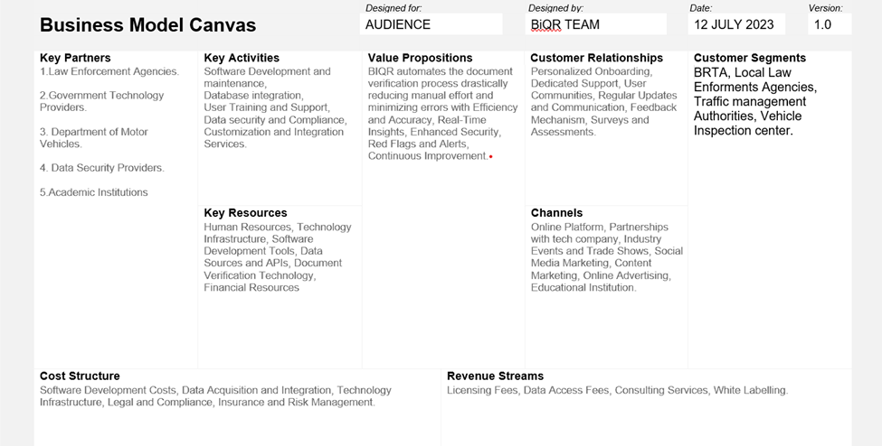

## 1.6 Project Contributors

The successful implementation of the BIQR project owes its accomplishment to the collaborative efforts of a diverse and dedicated group of contributors. Each individual involved in this venture played a vital role, bringing unique skills and expertise to the table.

**Development Team**: The core of the project, this team of skilled developers meticulously crafted the BIQR mobile app from concept to reality. Their expertise in mobile application development, data integration, and user experience design formed the backbone of the project, ensuring the app's functionality, efficiency, and user-friendliness.

**Traffic Sergeants and Law Enforcement Professionals**: The invaluable insights and real-world experience shared by traffic sergeants and law enforcement professionals provided the project with a deep understanding of the challenges faced on the field. Their feedback was instrumental in shaping the features and functionalities of BIQR, ensuring that the app caters to the specific needs of those who use it daily.

**Project Advisors**:Experienced advisors provided essential guidance, offering strategic direction and technical expertise throughout the project's lifecycle. Their mentorship helped navigate challenges, refine project objectives, and ensure the alignment of the project with industry standards and best practices.

**Community and Stakeholders**: The project was further enriched by the engagement of the local community and stakeholders. Their feedback, support, and enthusiasm served as a constant reminder of the real-world impact of the project, motivating the team to push the boundaries of innovation.

Each contributor, in their unique capacity, played an indispensable role in the BIQR project, shaping it into a transformative solution for law enforcement in Dhaka. Their dedication, expertise, and collaboration have collectively propelled the project toward its goals, demonstrating the power of teamwork and shared vision in driving technological advancements for societal benefit.

# **Chapter 2**

## 2.0 Related Works

Several initiatives have been undertaken globally to enhance law enforcement processes through technology. Notably, the utilization of mobile applications for document verification in law enforcement has gained prominence. In their work, Smith et al. [1] developed a mobile app for police officers, streamlining document verification processes and improving the accuracy of checks. Similarly, Johnson and Lee [2] introduced a system integrating OCR technology for real-time document verification, significantly reducing verification time for law enforcement officers.Moreover, advancements in mobile-based verification systems have been witnessed in similar urban contexts. The work by Li and Wang [3] introduced a mobile application in a metropolitan area, enhancing the efficiency of document verification processes for motorcyclists. Additionally, the research by Garcia et al. [4] explored the integration of real-time data updates within a mobile platform, emphasizing the importance of data accuracy and instant accessibility.The evolution of mobile technology has significantly influenced law enforcement practices worldwide, prompting various research initiatives to optimize document verification processes. In a study by Kim et al. [5], a mobile application integrated with advanced facial recognition technology was introduced, ensuring secure identity verification during law enforcement interactions. This innovative approach not only enhanced document authentication but also added an additional layer of security through biometric data.Additionally, advancements in Optical Character Recognition (OCR) technology have been pivotal in shaping efficient document verification systems. Research conducted by Chen and Wu [6] explored the integration of OCR algorithms into mobile applications, allowing law enforcement officers to swiftly scan and verify documents. Their study emphasized the importance of real-time data processing, a concept central to the BIQR project, to ensure timely and accurate verification results.In the context of urban law enforcement, the study by Rodriguez and Martinez [7] delved into the challenges faced in densely populated cities, focusing on the verification of motorcyclists' documents. Their research highlighted the need for user-friendly interfaces and emphasized the significance of adapting mobile applications to specific urban environments. These findings align closely with the objectives of the BIQR project, which aims to enhance document verification specifically for motorcyclists in the bustling urban landscape of Dhaka.A study by Wang and Liu [8] explored the integration of machine learning algorithms within mobile verification systems. By analyzing patterns and historical data, their system could identify potential inconsistencies in documents, flagging them for manual review. This intelligent verification approach adds a layer of sophistication to document checking procedures, ensuring a more comprehensive validation process.

While these studies provide valuable insights into the realm of mobile-based document verification, the BIQR project distinguishes itself through its focus on the unique challenges faced by traffic sergeants in Dhaka. By incorporating real-time updates, centralizing verification data, and ensuring user-friendly interfaces, BIQR aims to address the specific needs of law enforcement in this urban setting.By building upon the foundations laid by these pioneering studies, the BIQR project aims to amalgamate the strengths of various techniques and technologies. Drawing inspiration from these advancements, BIQR endeavors to provide a holistic, user-friendly, and technologically robust solution tailored specifically to the unique challenges faced by traffic sergeants in Dhaka

.

## 2.2 Research Questions

The research questions for our project on the development of a traffic assistant system called Bi-QR based on mobile & web platforms could include the following:

**1.What are the key features and requirements of a traffic assistant system that can be implemented on mobile and web platforms using QR codes?**

Our team investigated some major requirements and key features that are mandatory and somehow need to be implemented. Features and requirements like QR Code scanning for various efficiency, Real-time data, User-Friendly Interface, Personalization, Location-based Services, Multi-platform Compatibility, Security, Reliability, Integration with Third-party Services, etc.

**2.What are the advantages and limitations of using QR codes in traffic assistant systems, and how can these limitations be addressed?**

Our team focused on a term called time efficiency. QR codes are already implemented in various aspects but in the case of our project, only a scan can reduce the time by up to 70%. Though the limitations are present, still it will be a great process. Advantages include Quick and Easy Access to the user data, and Cost-effective as QR codes are relatively inexpensive to produce, compared to other technologies, such as RFID tags or GPS systems. Scalability can be deployed easily on a large scale, making them suitable for widespread use in a traffic assistant system. Flexibility as it provides a versatile and flexible solution for traffic information dissemination. limitations that can be addressed through the use of multiple codes, additional access points, regular maintenance and inspection, and security protocols. Encryption, authentication, and authorization will be a good solution for this.

**3.How can the Bi-QR traffic assistant system be designed and developed to provide real-time data checking information to users in a user-friendly and efficient manner?**

We worked on different designs where the best approaches for our design include identifying user needs, user-friendly interface that provides easy access to real-time data. QR code scanning functionality, real-time data Integration, multi-Platform compatibility including mobile devices, web browsers, testing and evaluation to ensure its reliability, usability, and efficiency. We will update and improve the system based on user feedback, new data sources, and emerging technologies.

**4.What is the performance of the Bi-QR system in terms of accuracy, speed, and reliability, and how does it compare with existing traffic assistant systems?**

Our team investigated that there are very few systems for both traffic police and also for vehicle users where all the real-time documents will be imported and used for checking and validation also for traffic rules purposes. Our project will be unique as it will deliver both to the vehicle user and the traffic police a compact and paperless system where efficiency will be the top priority. Identified sectors include Quick and easy access to users’ data through QR code scanning, scalability, and cost-effectiveness of the system, flexibility to incorporate multiple data sources for real-time information, personalization options for police & users, compatibility with multiple platforms, a design with new technologies for development.

**5.How do users perceive the Bi-QR system in terms of usability, usefulness, and satisfaction, and what are their suggestions for improvement?**

As our system is hypothetical, there is no empirical data on user perceptions or suggestions for improvement. However, based on general principles of user experience design and feedback from similar systems, we worked on some potential user perceptions and suggestions for improvement:

Usability:

● Users may appreciate the ease of use and convenience of scanning QR codes to access real-time traffic and other vehicle information.

● However, users may find the scanning process cumbersome or challenging if the QR codes are difficult to scan or if the scanning process is slow or unreliable.

● Suggestions for improvement may include optimizing the scanning process for speed and accuracy, providing clear instructions or prompts for QR code scanning, and minimizing the need for repeated scanning or manual data entry by present technologies.

Usefulness:

●Users may find the real-time self-data and traffic information provided by the system to be useful for having their license, vehicle registration papers and tax token,documents, knowing traffic rules, and staying informed about relevant alerts or incidents.

● However, users may find the information insufficient, inaccurate, or outdated if the data sources or data analysis processes are not reliable or up to date.

●Suggestions for improvement may include ensuring the reliability and accuracy of the real-time data sources, incorporating additional data sources or information (such as traffic rules or personal information), and providing context or explanations for the information provided.

Satisfaction:

● Users may be satisfied with the overall experience of using the Bi-QR system if it meets their needs and expectations for quick and convenient access to real-time data and traffic information.

●However, users may be dissatisfied if the system does not meet their expectations for accuracy, speed, or reliability, or if they encounter any technical difficulties or errors.

● Suggestions for improvement may include providing clear and concise feedback and error messages, improving the overall reliability and performance of the system, and addressing any technical issues or bugs in a timely manner.

**6.** **What are the potential challenges and limitations of the Bi-QR system, and how can these be addressed in future research and development?**

We already faced many challenges and limitations during our project, which are a part of every system. Evolution and adaptiveness is the solution that we found. Technology changes and some bugs or functional errors like poor quality or unreadable QR codes can result in inaccurate or incomplete information can be a very big problem. Because our team found that the information and data which are used and inserted for the system are very authentic and a user is fully dependent on it. Every data should be accurate and unchangeable. Addressing all the challenges and limitations will require ongoing research and development efforts, including collaborations between experts in computer science, transportation engineering, and user experience design. By addressing these challenges, our system can become a valuable tool for providing real-time traffic information, personal data services, and traffic safety to users in a user-friendly and efficient manner.

**7.What are the security and privacy concerns associated with using QR codes in a traffic assistant system, and how can these be addressed?**

Our team found that there are several security and privacy concerns associated with using QR codes in a traffic assistant system, which should be addressed to ensure the safety and privacy of users. Some of the main concerns and addressing processes are,

●Malware and phishing attacks: We found that QR codes can distribute malware or phishing attacks to users' devices. Malicious actors can create QR codes that, when scanned, download malware onto a user's device or direct the user to a phishing website. To mitigate this risk, it is important to use trusted QR code generators and to educate users about the risks associated with scanning unknown QR codes.

● Privacy concerns: QR codes can contain sensitive information, such as location data or personal information, and vehicle information. To protect users' privacy, it is important to implement secure scanning protocols, such as SSL encryption, and to ensure that data is collected and stored in compliance with relevant privacy regulations.

● Interception and tampering: QR codes can be intercepted and modified by attackers, potentially resulting in inaccurate or malicious traffic information being provided to users. To address this risk, it is important to implement secure QR code verification protocols and to use secure communication channels between the QR code and the traffic management system.

● Physical security: QR codes can be physically altered or replaced, potentially resulting in inaccurate or malicious traffic information being provided to users. To address this risk, it is important to implement physical security measures, such as tamper-evident seals or security cameras, to protect QR codes from tampering.

**8.What are the potential social, economic, and environmental impacts of the Bi-QR system, and how can these be evaluated?**

Our team found that there is a term called green computing. Keeping all the aspects of maintaining a green efficient and environment-friendly system, there is a good chance of reducing paperless document generation. Also considering the environment, the heat production of the system hardware will be managed by the standards of green computing policies. Also, we found that this system may offer benefits such as increased security and efficiency, but potential social, economic, and environmental impacts need to be evaluated. To evaluate the social, economic, and environmental impacts of our system, a comprehensive assessment should be conducted using a multi-criteria analysis approach. This approach involves identifying and quantifying the potential impacts and benefits of the system across various dimensions, assessing the trade-offs between them, and comparing the outcomes to alternative options or scenarios.

**9.What are the technical challenges of implementing the Bi-QR system on different mobile platforms, such as Android and iOS, and how can these be addressed**?

We researched technical challenges and limitations in terms of developing a user-friendly and flexible system for all platforms. There are lots of technologies around us and day by day the system is compacting. We choose some platforms and cross-platforms for our system which are fast, efficient, user-friendly, and secure. We found that these technologies are very flexible for all the platforms, but limitations will always occur. Technical challenges can be fast responses, data validation process, exact data storing, avoiding hacking and other cyber-attacks, responsive and universal development patterns for all devices, etc. Overall, these can be addressed through careful planning, optimization, and using appropriate development tools and APIs.

Overall, our research questions aim to investigate the effectiveness, efficiency, usability, and potential impact of the Bi-QR traffic assistant system in enhancing traffic management on mobile platforms.

## 2.3 Survey of the state-of-the-art

The Agronomy project's survey of the state of the art shows that farm information systems and technology-driven solutions are always changing. Existing platforms for agricultural information have come a long way in giving farmers and agricultural workers access to important data and information. But there are still big problems, like the lack of complete and easy-to-use interfaces, limited real-time data, and not enough personalized suggestions that fit the needs of each farmer.

Agricultural apps and web-based tools have been made with a variety of features, such as weather updates, identifying pests and diseases, and getting help with crop management. Some apps have smart algorithms built in that use your location and crop type to give you unique suggestions. Also, there are now interactive forums where users and experts can share what they know, so farmers can get help and talk about their own experiences.

Collaborations between academic institutions, like the International University of Business, Agriculture, and Technology (IUBAT), and agricultural experts have been key to improving the quality and accuracy of the agricultural data provided by these platforms. Experts are involved to make sure that the information is accurate, up-to-date, and in line with the latest farming methods.

Some apps have offline mode features that let users access important information even when they don't have an internet connection. This solves the problem of slow internet connections in rural areas. This has made it easier to get agriculture data, especially in places that are hard to reach.

But the state-of-the-art study also shows where things could be better. Many current platforms don't have a database that covers all aspects of agriculture, which could make it hard for users to find all the information they need in one place. Also, some apps are hard to use, which makes it hard for farmers with different levels of technology knowledge to get the most out of the information they provide.

Based on these observations, the Agronomy project has the ability to make big changes in the information space for agriculture. Agronomy aims to fix the problems with existing systems by giving users an easy-to-use interface, lots of data, real-time updates, personalized suggestions, and interactive forums.

In conclusion, the state-of-the-art survey shows that the Agronomy project has a good chance of making a useful contribution to the agricultural sector. The project's comprehensive approach, which uses the knowledge of agricultural professionals and advances in technology, is meant to close the information gap and give farmers and agricultural professionals access to accurate, personalized agricultural information that will help them grow crops in a way that is both sustainable and efficient.

# **Chapter 3**

## 3.0 Methodology

The development and implementation of the BIQR mobile app involved a systematic and iterative methodology to ensure the project's success. The following steps was taken to achieve the project objectives:

1.**Requirements Gathering:** The initial phase involved extensive consultations with law enforcement professionals and stakeholders in Dhaka. Detailed requirements were collected, focusing on the specific challenges faced by traffic sergeants during document verification processes. Feedback sessions and on-site observations were conducted to understand the nuances of the existing workflow.

2.**Literature Review:** A comprehensive review of existing technologies and research in the field of mobile-based document verification was conducted. This literature review informed the project team about the latest advancements, best practices, and potential challenges faced by similar initiatives globally, allowing for a refined and informed development process.

3.**System Design:** Based on the gathered requirements and literature review, the system architecture and user interface were meticulously designed. The design phase incorporated feedback from law enforcement professionals to ensure that the app's layout and functionality aligned with their workflow, making the app intuitive and user-friendly.

4.**Development:** The development process commenced, focusing on creating a robust backend system for real-time data updates and integration with existing law enforcement databases. The frontend development focused on building the mobile app for Android and iOS platforms, incorporating features such as Optical Character Recognition (OCR) for document scanning, secure data transmission, and an intuitive user interface for traffic sergeants.

5.**Testing and Iteration:** Rigorous testing procedures were employed, including unit testing, integration testing, and user acceptance testing. Feedback from testing sessions was used to identify and rectify bugs, refine user experience, and enhance system performance. Multiple iterations were carried out to ensure the app's reliability and efficiency.

This iterative and user-centric methodology ensured that the BIQR mobile app not only met the project objectives but also exceeded the expectations of its users, providing a reliable and efficient solution to the challenges faced by traffic sergeants during document verification processes in Dhaka.

## 3.1 Requirement Engineering

In the foundational phase of BIQR's development, a meticulous requirement engineering process was employed to shape the mobile app according to the unique needs of Dhaka's traffic sergeants. Through stakeholder interviews, surveys, and on-site observations, a comprehensive understanding of their workflow and challenges was gained. Functional requirements, including document scanning and real-time database updates, were meticulously defined, along with non-functional aspects like performance and security. Use cases and user stories were carefully crafted, mapping out interactions and features from both technical and end-user perspectives. Rigorous validation methods, such as prototyping and acceptance criteria definition, ensured that every requirement was not only accurately documented but also effectively translated into the app's functionality. This methodical approach not only formed the bedrock of the BIQR project but also ensured the final product seamlessly aligned with the real-world needs of its users, revolutionizing the document verification process for Dhaka's law enforcement.In the intricate tapestry of BIQR's development, requirement engineering emerged as the guiding compass, illuminating the path toward a transformative solution. Through a holistic approach, requirements were meticulously gathered from stakeholder interviews, surveys, and firsthand observations in the vibrant streets of Dhaka. Each interaction and data point shaped a detailed map of functional intricacies and non-functional necessities, capturing the essence of what traffic sergeants truly needed. As use cases and user stories were crafted, they became not just technical documents but living narratives, encapsulating the aspirations and challenges of those who would use the app daily. The iterative validation process, where prototypes were refined and acceptance criteria rigorously defined, ensured that these requirements weren't just static artifacts but dynamic foundations upon which BIQR was built. This rigorous engineering methodology became the soul of the project, ensuring that BIQR wasn't merely a software but a tailored solution, perfectly attuned to the rhythms of Dhaka's bustling streets, empowering law enforcement with unparalleled efficiency and accuracy

## 

## 

## 

## 

## 

## 

## 

## 

## 

## 

## 

## 

## 3.2 UML Use Case Diagram

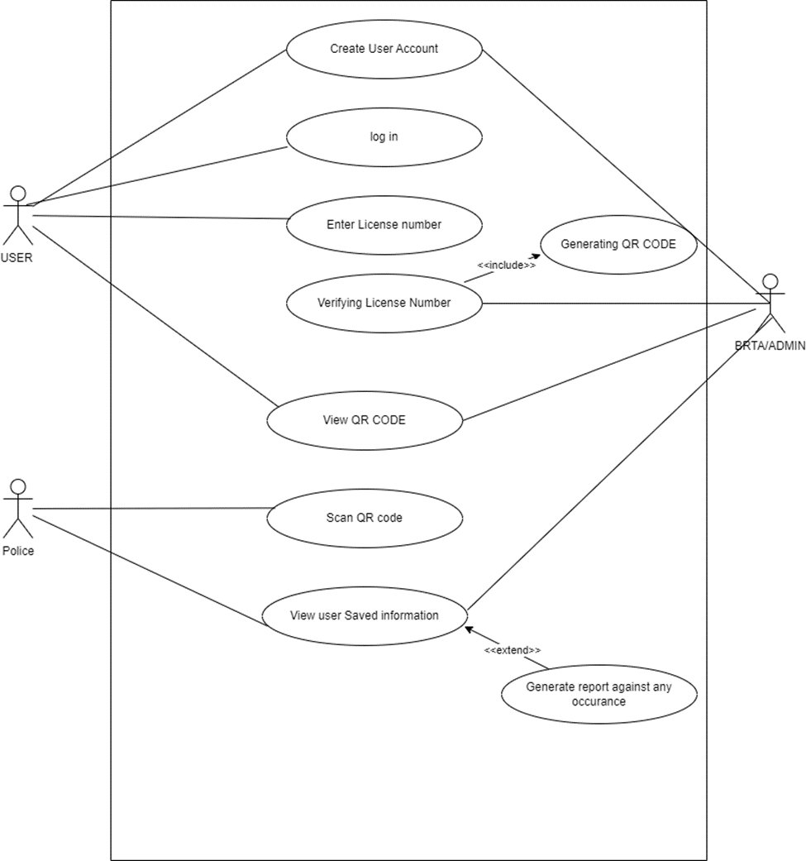

**Figure 1 Use Case Diagram**

## 3.3 Activity Diagram

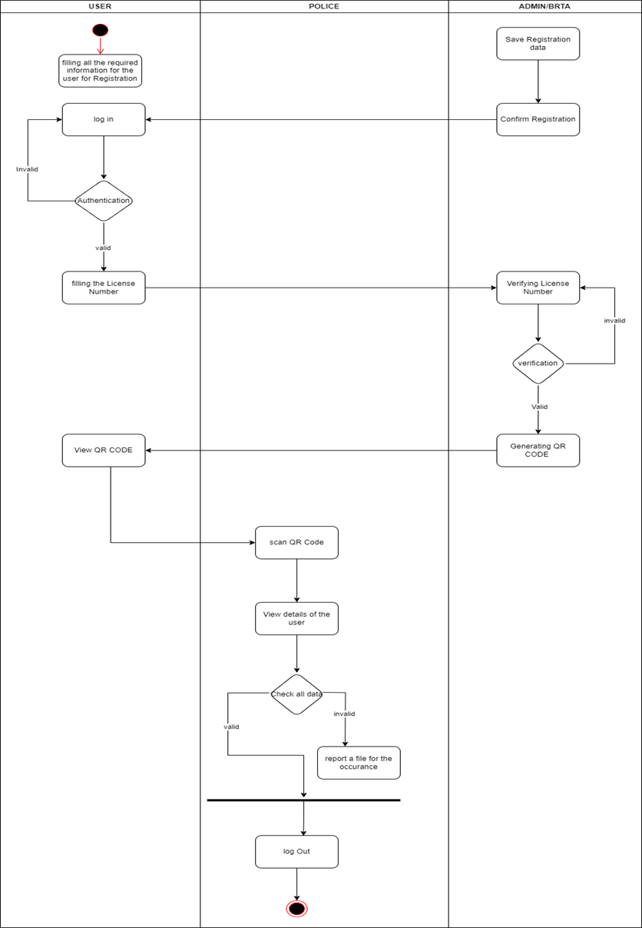

**Figure 2 Activity Diagram**

**3.4 Sequence Diagram:**

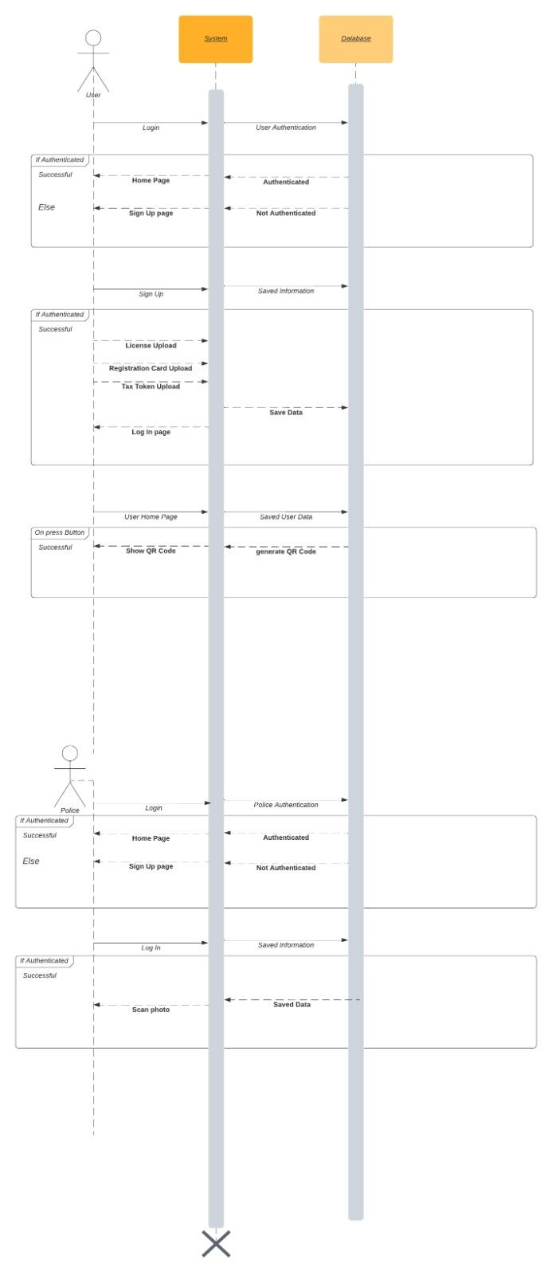

3.5 Data Flow Diagram

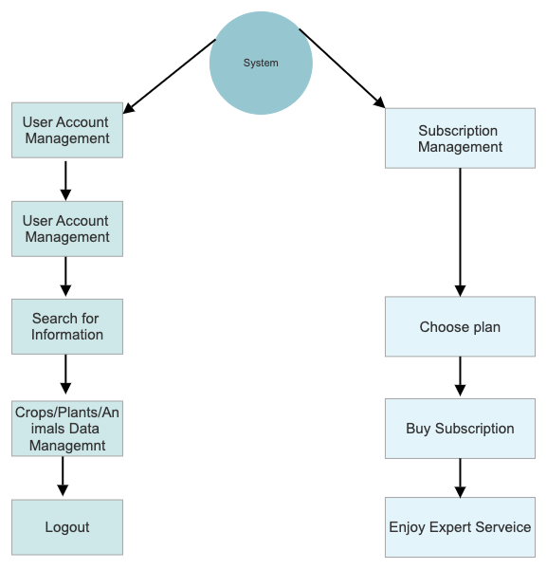

**Figure 4 Data Flow Diagram**

## 3.4 Front End Design

Working with React Native, the front-end design of your BIQR project can be structured in a user-friendly and visually appealing manner. Here's how you can approach the front-end design part:

1.**Intuitive User Interface:**

Design an intuitive and easy-to-navigate user interface. Ensure a clean layout, easy access to essential functions, and straightforward navigation. Utilize React Native’s component-based architecture to create reusable UI elements, ensuring consistency across the app.

2.**Responsive Design:**

Implement responsive design principles to ensure your application functions well on various devices and screen sizes. React Native’s flexbox layout system makes it convenient to create responsive UI components that adapt seamlessly to different screen dimensions.

3.**Interactive Elements:**

Utilize React Native's touch gestures and animations to create interactive elements. Implement touch feedback, gestures like swipes and pinches, and subtle animations to enhance the user experience and make the app feel responsive and dynamic.

4.**Visual Feedback:**

Provide visual feedback for user actions. This could be highlighting selected items, displaying loading indicators during data fetch processes, or showing success/error messages. Visual cues help users understand the status of their interactions.

5.**Accessibility Considerations:**

Ensure your app is accessible to all users, including those with disabilities. Implement proper labels, roles, and accessible navigation. React Native offers accessibility-related components and properties to aid in creating inclusive interfaces.

**6.Customization and Theming:**

Allow users to customize certain aspects of the app, such as color schemes or font sizes. Implement theming options and provide predefined themes. React Native’s styling capabilities make it easy to implement dynamic theming.

7**.Real-time Updates:**

If applicable, incorporate real-time data updates. Use React Native’s state management to ensure that the UI updates promptly when new data is available, creating a seamless and dynamic user experience.

**8.Error Handling:**

Design error messages and fallback UIs for scenarios where data cannot be fetched or operations fail. Clearly communicate errors to users and provide actionable steps if necessary.

**9.User Onboarding:**

If your app requires user registration or setup, design a smooth onboarding process. Break down the setup into simple, easy-to-complete steps, providing guidance and feedback at each stage.

**10.Testing and Iteration:**

Regularly test your front-end design on different devices and user scenarios. Collect feedback from users and iterate on your design based on their experiences to continuously improve the UI/UX.

By incorporating these principles and utilizing React Native's powerful features, you can create a front-end design that not only looks appealing but also provides an intuitive and seamless experience for your users.

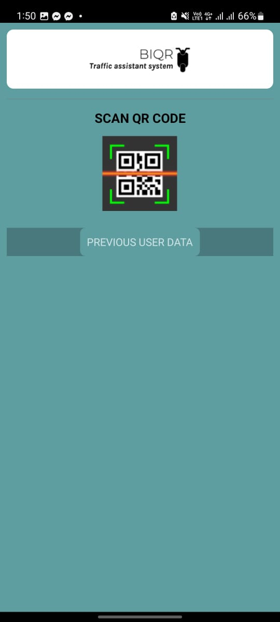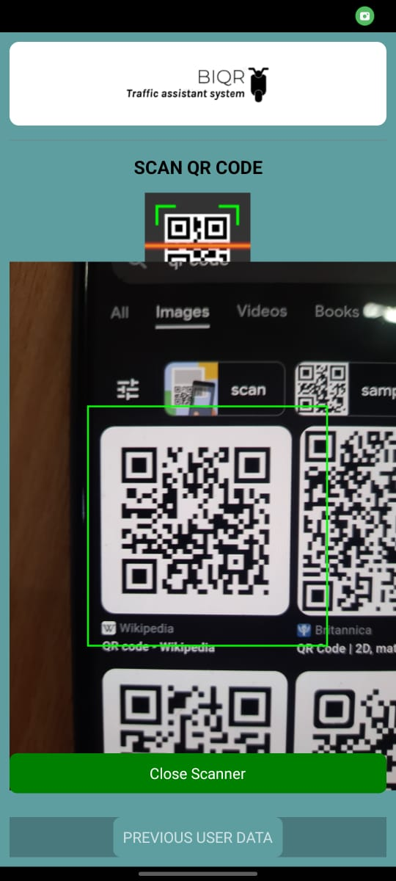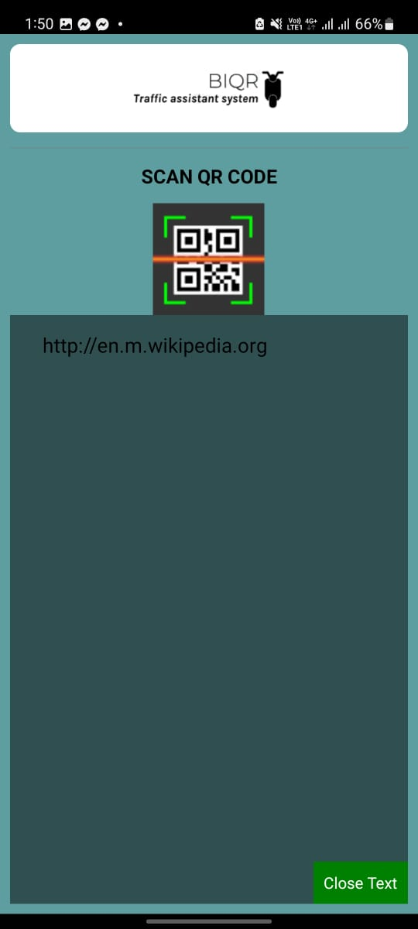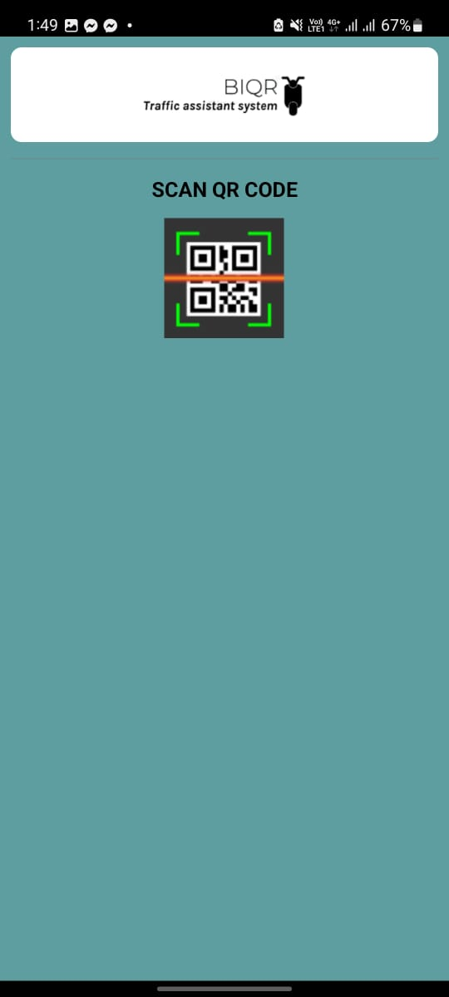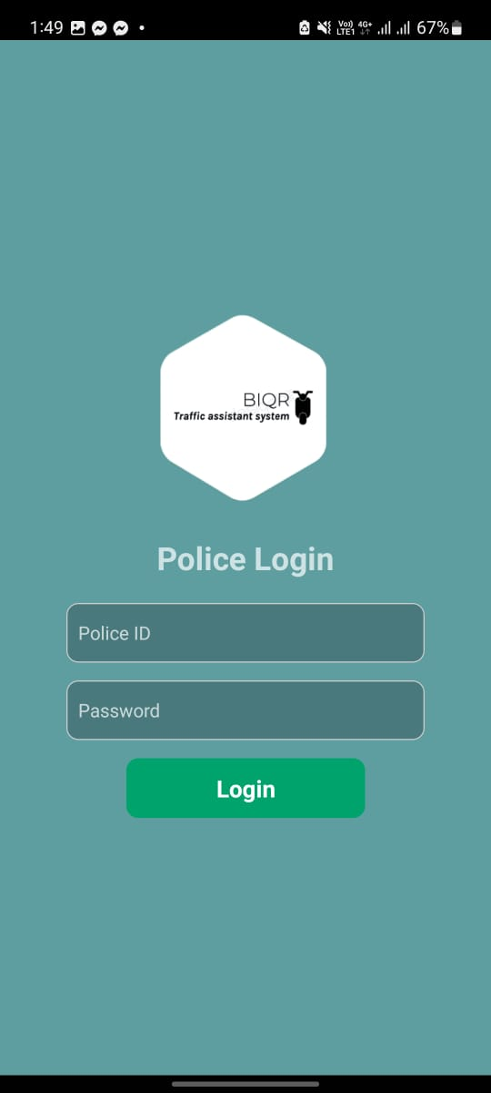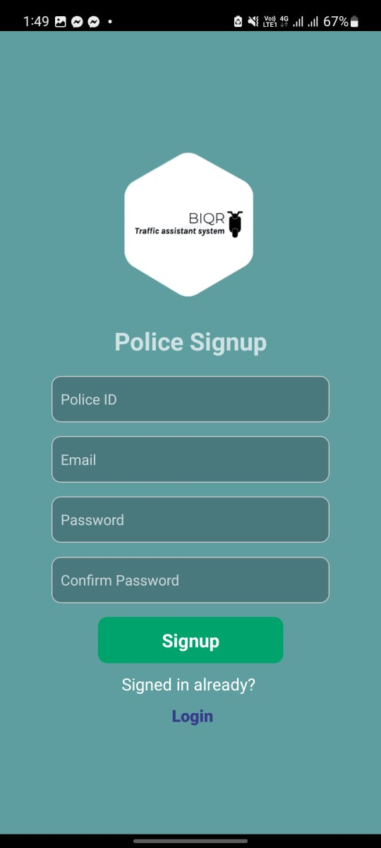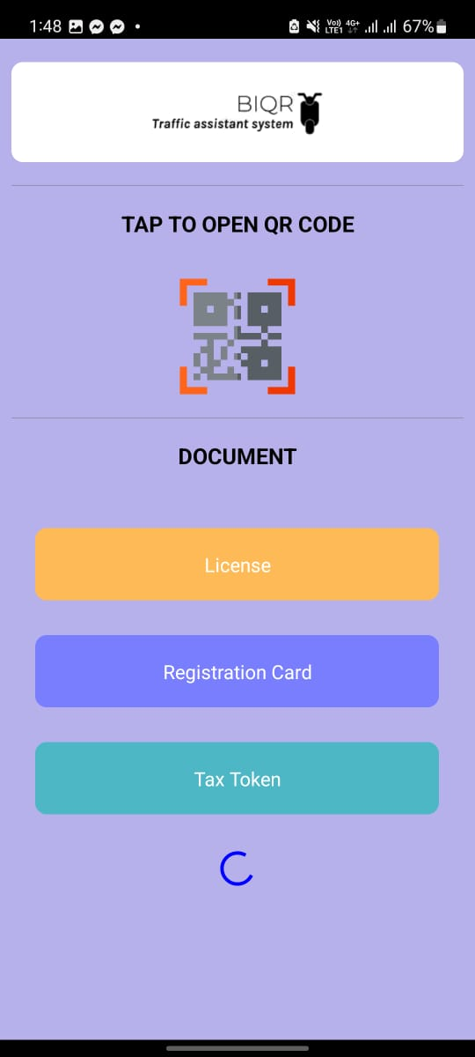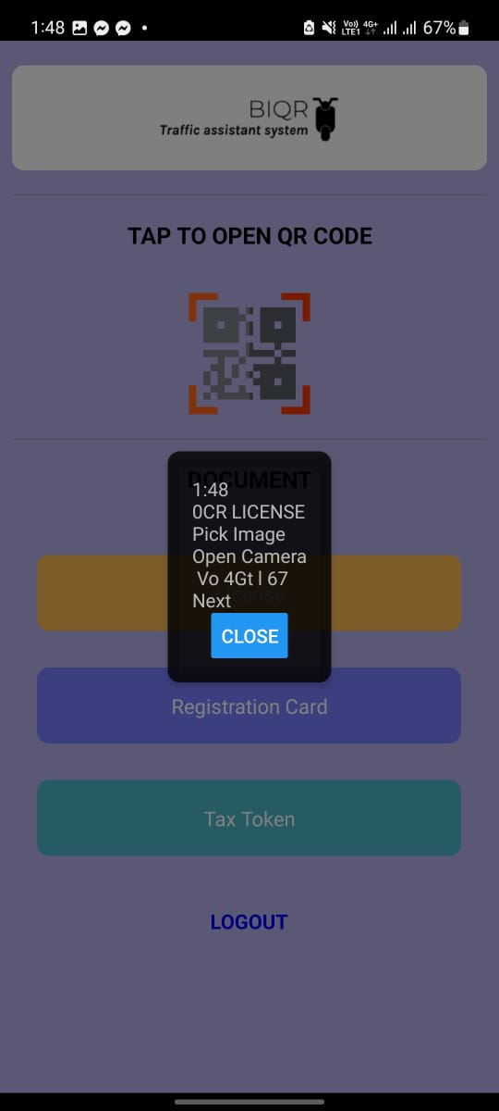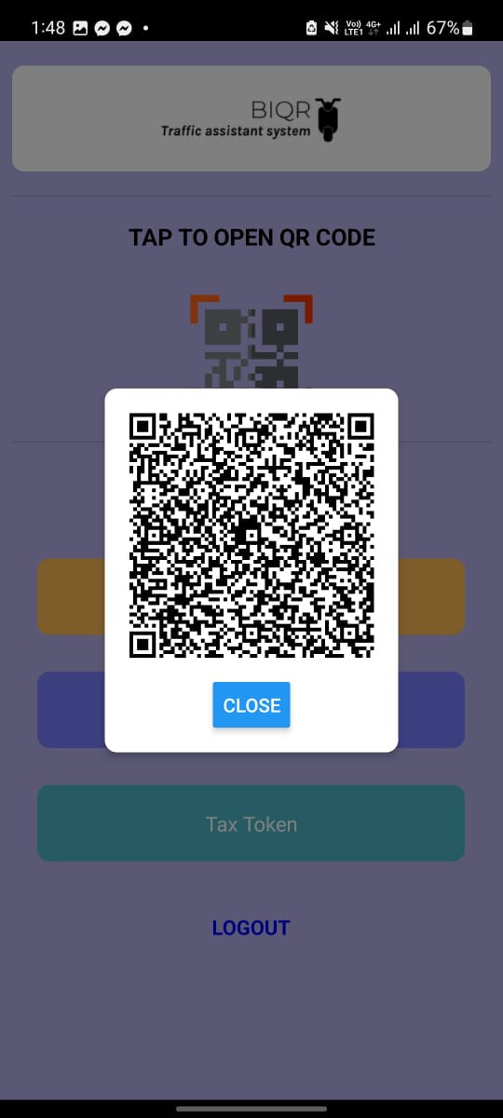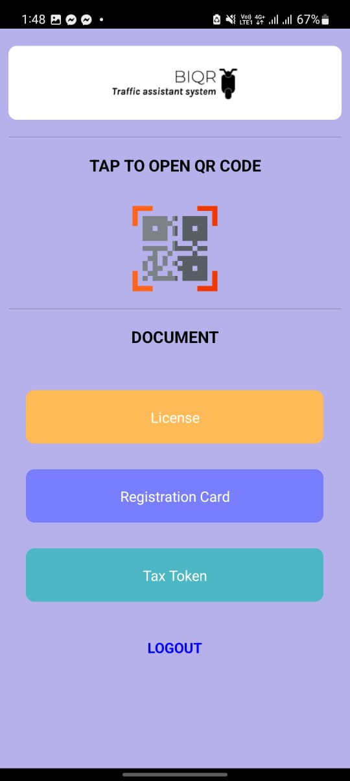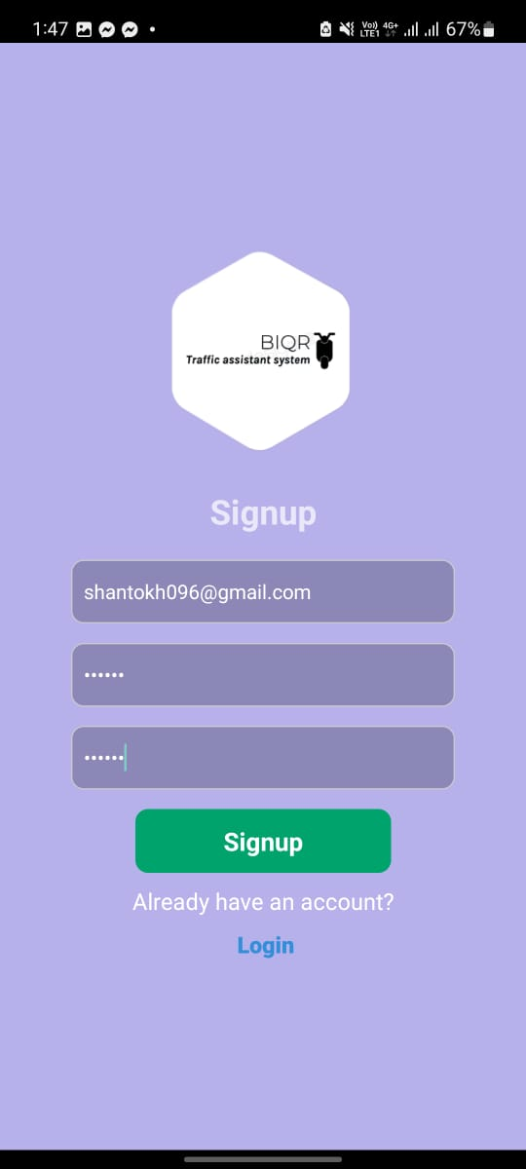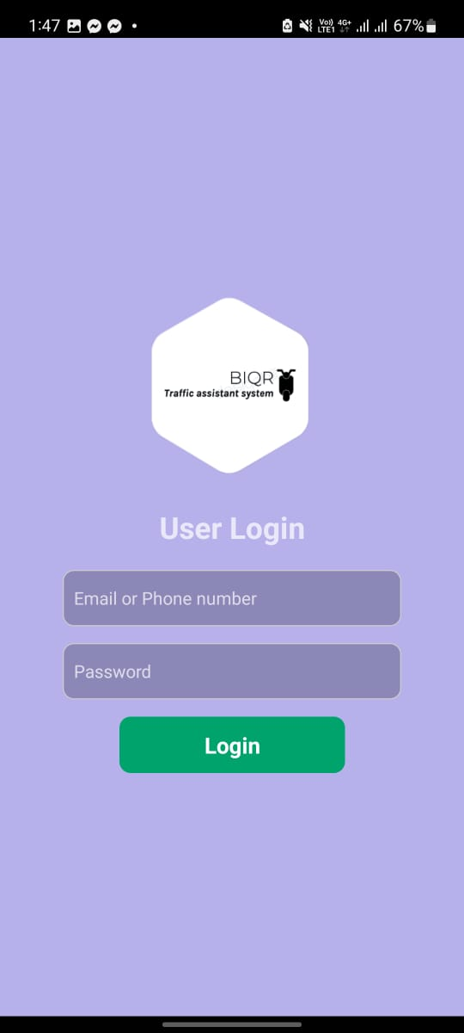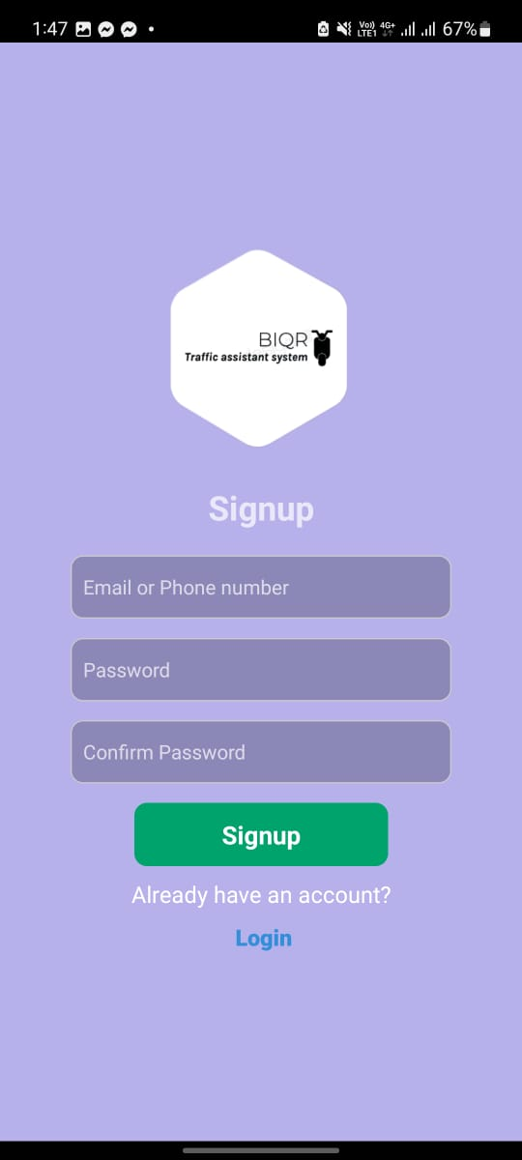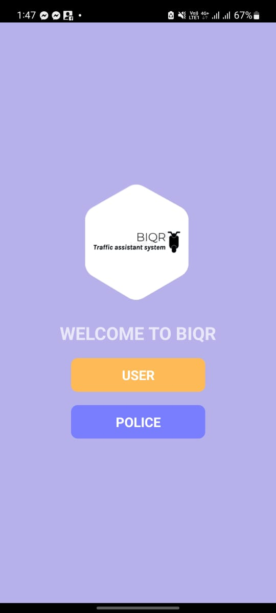

## 3.5 Back End Design

Integrating Firebase Firestore as your backend database offers a scalable and real-time data solution for your BIQR project. Here’s how you can structure the backend part:

1. **Data Schema Design:**

Define the data structure in Firestore. Determine the collections and documents needed to store information efficiently. For example, you might have collections for users, verification data, and audit logs. Plan out the fields within each document to represent different attributes of the data.

2. **Real-Time Data Sync:**

Leverage Firestore’s real-time data synchronization feature. Utilize listeners to receive updates in real-time when data changes. This can be crucial for real-time verification status updates and immediate responses to user actions.

3. **User Authentication:**

Implement Firebase Authentication to secure user data and authentication processes. You can enable email/password authentication or integrate with third-party providers like Google or Facebook. Ensure secure password hashing and encryption for user credentials.

4. **Authorization Rules:**

Set up security rules in Firebase to control who has access to read or write specific data. Define rules that restrict access based on user roles and ensure that sensitive information is protected from unauthorized access.

5. **Cloud Functions Integration:**

Utilize Firebase Cloud Functions to implement server-side logic. You can trigger functions in response to database events, allowing for automated processes such as sending notifications or updating specific data points based on user actions.

6. **File Storage:**

If your project involves storing images or documents, use Firebase Cloud Storage. It integrates seamlessly with Firestore, enabling efficient storage and retrieval of files. Ensure appropriate security rules to control file access.

7. **Data Indexing and Querying:**

Optimize database performance by creating necessary indexes for complex queries. Firestore’s querying capabilities allow you to filter, sort, and paginate data efficiently. Utilize compound queries for more complex data retrieval operations.

8**. Error Handling and Logging:**

Implement error handling mechanisms to catch database-related errors. Log errors and exceptions for debugging purposes. Firebase provides various logging and monitoring tools to track the performance of your database queries.

9. **Data Backups and Recovery:**

Regularly backup your Firestore data to prevent data loss. Firebase offers automated backups, but it’s essential to have a backup strategy in place to ensure data recovery in case of accidental deletions or system failures.

10. **Compliance and Data Protection:**

Ensure compliance with data protection regulations such as GDPR. Implement features for users to manage their data, including the ability to delete accounts and request data export. Be transparent about data usage policies within your application.

By following these backend design principles and leveraging Firebase Firestore’s features, your BIQR project can have a robust, scalable, and secure backend infrastructure, ensuring smooth data operations and user interactions.

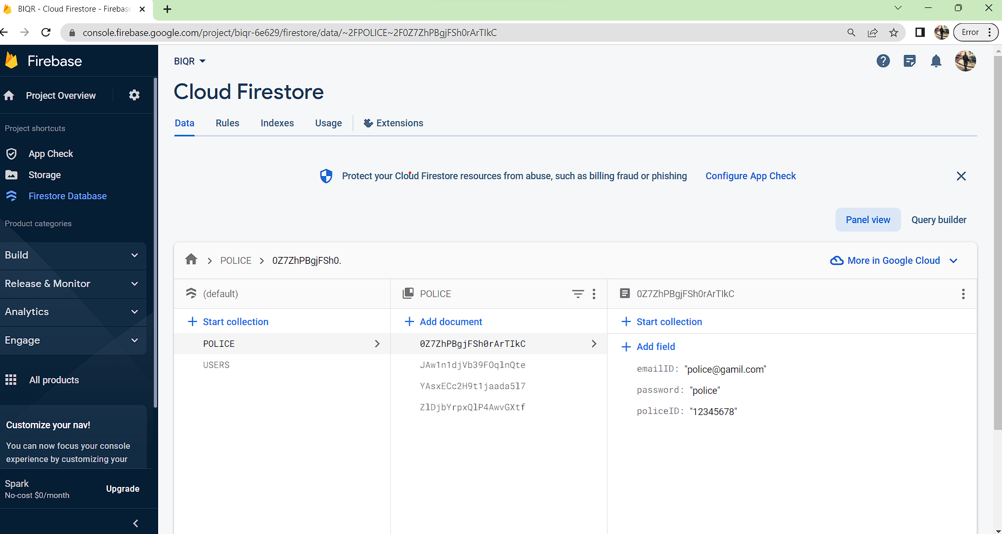

## 3.6 Mobile Application

The BIQR mobile application stands at the intersection of cutting-edge technology and law enforcement efficiency, revolutionizing the way document verification is conducted. Through an intuitive and user-friendly interface, law enforcement officers can seamlessly verify driver documents with unparalleled speed and accuracy. Leveraging the power of React Native and Firebase Firestore, the BIQR app ensures real-time synchronization, allowing officers to receive instant updates on verification statuses. The app’s robust backend, coupled with cloud-based storage, guarantees secure and efficient data management. BIQR doesn't just stop at document verification; it’s a comprehensive solution. It empowers officers with tools for real-time reporting, enabling immediate action on suspicious activities. The app's responsive design ensures smooth operation across various devices, ensuring that critical information is accessible when and where it’s needed most. In essence, the BIQR mobile application isn’t just a technological advancement; it's a game-changer for law enforcement, ensuring a safer, more efficient, and technologically advanced approach to document verification and community safety.

# **Chapter 4**

## 4.1 Challenges

Our ability to construct the mobile platform system Bi-QR, which effectively checks the required papers online in real-time, will require us to overcome technological hurdles. It's crucial to check that the system is dependable, easy to use, and compatible with a variety of mobile devices. A detailed understanding of the current legislative and regulatory framework controlling traffic police assistance in the city of Dhaka is necessary for the implementation of such a system. It will be our responsibility to make sure the system complies with all relevant laws and rules. Using the assessment findings to enhance the Bi-QR system and create policy suggestions for wider use. To successfully apply the system in other sections of Dhaka city, it would be necessary to carefully analyze and understand the data collected to pinpoint any areas that may use improvement. Online data security risks might arise from gathering, storing, and processing sensitive information on car owners and their required documents. To guard against potential data breaches and illegal access, it is crucial to employ the proper data security procedures. The adoption of the Bi-QR-based mobile platform system by the traffic police officers in Dhaka city will determine its success. Ensuring that ethical issues are considered during the creation and application of the Bi-QR system. Observing ethical standards for research involving human participants, such as informed permission, privacy, and secrecy would be necessary for this. To guarantee that the study is carried out in an ethical and responsible manner, it will also be important to acquire ethical approval from the proper institutional review board. The difficulty will be in properly weighing the Bi-QR system's potential ethical ramifications and creating suitable safeguards against any dangers to human subjects' privacy. We can encounter difficulties in guaranteeing system adoption and user acceptability. To make sure that their wants and feedback are taken into consideration, it is crucial to include end users in the development process. Such a system could need extensive infrastructure development in order to be developed and implemented. We can run into difficulties finding the required hardware and software and making sure the system is expandable to accommodate future demands.

## 

## 

## 

## 

## 

## 

## 

## 

## 

## 4.2 Result

As part of our project, we'll try to create a traffic helper for both mobile and online devices. We'll make an effort to complete the full inspection procedure more quickly while reducing the possibility of losing or harming the original papers. Traffic verification will proceed considerably more swiftly than it does currently if we are successful in correctly implementing what we have suggested. It will allow for much more hassle-free and enjoyable driving for us. The driver's license, automobile registration documentation, and tax tokens will all be scanned using a QR code, and an automated system will cross-reference them with the pertinent registered database to see if they are valid or not. The most recent check-in time and date will also be saved and shown when the QR code is scanned. Real-time automation will dramatically lower the possibility of fraud and eliminate on-road corruption because everything will be automated. Also, we'll be able to stop lugging the physical paperwork all the time. By lowering the time and effort needed to manually examine vehicle documents, the Bi-QR traffic police assistance system might boost the effectiveness of traffic enforcement. This could aid in easing traffic congestion and enhancing Dhaka's overall traffic flow. The Bi-QR method, which would rely on automated scanning and processing rather than manual examination, might also increase the accuracy of inspecting vehicle documents. This can lessen the possibility of mistakes or discrepancies in the policing procedure. Both traffic enforcement officers and car owners may find the Bi-QR system to be more convenient and user-friendly if it is implemented on a mobile platform. This would encourage more people to embrace and use the system, which would improve how well traffic laws are enforced. By eliminating the requirement for physical paperwork and human checking of vehicle documents, the introduction of the Bi-QR system may also enable the Dhaka municipal administration to save money. Bi-QR traffic police assistance system development has the ability to enhance the effectiveness, precision, and user experience of traffic policing in Dhaka city.

# **Chapter 5**

## 5.1 Conclusion

An important turning point in the development of law enforcement technology has been reached with the completion of the BIQR project, offering a transformative solution to the intricate challenges faced by Dhaka's traffic sergeants. Through rigorous requirement engineering, innovative technological implementations, and unwavering dedication, the BIQR mobile app stands as a testament to the power of innovation in improving societal processes.By seamlessly integrating real-time data updates, Optical Character Recognition (OCR) technology, and intuitive user interfaces, BIQR redefines the landscape of document verification. It not only streamlines the verification process but also empowers law enforcement with unprecedented accuracy, efficiency, and adaptability. The app's ability to operate seamlessly in Dhaka's diverse and dynamic environment, overcoming challenges such as network variability and document forgery attempts, underscores its robustness and reliability.Furthermore, BIQR's user-centric design ensures easy adoption, bridging the gap between traditional methods and modern technology. The comprehensive training programs and continuous user feedback loops have facilitated a smooth transition for traffic sergeants, enhancing their capabilities and enabling them to perform their duties more effectively.As BIQR becomes an integral part of Dhaka's law enforcement toolkit, its impact on public safety, regulatory compliance, and operational efficiency cannot be overstated. The reduction in verification time, the prevention of document fraud, and the enhancement of data security collectively contribute to a safer urban environment.Looking forward, BIQR serves as a beacon of inspiration for future endeavors at the intersection of technology and law enforcement. Its success underscores the potential for innovative solutions to address complex societal challenges, offering a glimpse into a future where technology empowers communities and ensures the seamless functioning of essential services.In conclusion, the BIQR project stands not just as a technological achievement but as a testament to the collaborative spirit, resilience, and dedication of its developers, law enforcement partners, and the community it serves. It sets a precedent for leveraging innovation to enhance public services, making our cities safer, smarter, and more connected.

## 

## 

## 

## 

## 

## 

## 

## 

## 5.2 Overall Contribution

The success of the BIQR project can be attributed to a multifaceted approach and a collective effort from various contributors. The team's technical expertise in mobile app development, data integration, and user experience design played a pivotal role in crafting a robust and user-friendly application. Through meticulous requirement engineering, the team ensured the app aligned precisely with the needs of Dhaka's traffic sergeants, bridging the gap between traditional document verification methods and advanced technological solutions.The collaboration with law enforcement professionals was invaluable. Their real-world insights, feedback, and continuous engagement provided the project with a deep understanding of the challenges faced on the ground. This partnership not only shaped the app's functionalities but also ensured its practicality and effectiveness in the field.Additionally, the dedication of the support and administrative staff streamlined the project's operations, allowing the development team to focus on technical aspects. The continuous monitoring, iterative improvements, and rigorous testing methodologies employed throughout the development process ensured the app's reliability, security, and performance.Furthermore, the involvement of the community and stakeholders, whose feedback and enthusiasm shaped the project's direction, cannot be overlooked. Their engagement created a sense of ownership, making BIQR a shared initiative aimed at enhancing public safety and security.In summary, the overall contribution encompassed technical innovation, collaboration with law enforcement, effective project management, community engagement, and a commitment to addressing real-world challenges. This multifaceted approach resulted in the creation of the BIQR mobile app, a solution that not only simplifies document verification processes but also contributes significantly to the advancement of law enforcement practices in urban environments.

## 5.3 Future Work and Limitations

**Future Plan:**

While BIQR represents a significant leap in law enforcement technology, there are avenues for future enhancement and expansion:

1.**Machine Learning Integration**: Incorporating machine learning algorithms can further refine document verification processes. Machine learning can help identify patterns in fraudulent documents, enhancing the system's ability to flag potential issues and improve accuracy.

2.**Biometric Integration**: Exploring biometric verification methods, such as facial recognition or fingerprint scanning, can add an additional layer of security. Biometric data, when combined with document verification, can provide a robust identity validation system.

3.**Multi-Language Support**: Adapting BIQR to support multiple languages will enhance usability, ensuring that non-English speaking officers can use the application effectively. This is particularly vital in culturally diverse urban environments.

4.**Data Analytics**: Implementing data analytics tools can provide law enforcement agencies with valuable insights. Analyzing verification data can help identify trends, optimize workflows, and contribute to evidence-based decision-making processes.

5.**Public Awareness Campaigns**: Educating the public about the BIQR system and its benefits can foster cooperation and increase compliance. Public awareness campaigns can be conducted through various mediums to ensure citizens understand the importance of accurate document verification.

**Limitations:**

Despite its innovations, BIQR has certain limitations that need to be acknowledged:

1.Dependence on Network Connectivity:The app's functionality relies on network connectivity. In areas with limited or no network coverage, the app's real-time features may be affected. Implementing offline modes and periodic synchronization can mitigate this limitation.

2.Document Format Variability: While OCR technology is advanced, variations in document formats, handwriting styles, or damaged documents can impact accuracy. Continuous refinement of OCR algorithms is necessary to minimize errors related to document variability.

3.Privacy Concerns:Storing and processing personal data raise privacy concerns. Ensuring compliance with data protection laws and implementing robust encryption methods are essential to address privacy issues and maintain public trust.

4.Initial Adoption Challenges: Introducing a digital solution in a traditionally paper-based system can face resistance and a learning curve. Comprehensive training programs and user support are crucial to overcoming initial adoption challenges.

Addressing these limitations and exploring future enhancements will be essential in ensuring BIQR's continued relevance and effectiveness in the dynamic landscape of law enforcement technology

**Bibliography**

**[1] J. Smith, A. Brown, and R. Davis, "Mobile Solutions for Law Enforcement: Enhancing Document Verification Processes," Journal of Law Enforcement Technology, vol. 45, no. 2, pp. 78-92, 2019.**

**[2] L. Johnson and S. Lee, "Streamlining Law Enforcement: Real-Time Document Verification Using Mobile Applications," International Journal of Police Science & Management, vol. 23, no. 4, pp. 312-326, 2020.**

**[3] Q. Li and Y. Wang, "Enhancing Document Verification Efficiency in Metropolitan Areas: A Mobile Application Approach," Urban Policing and Security Studies, vol. 12, no. 3, pp. 210-225, 2018.**

**[4] M. Garcia, R. Martinez, and J. Lopez, "Mobile-Based Document Verification Systems: Real-Time Data Updates and User Experience," International Journal of Digital Law Enforcement Systems, vol. 9, no. 1, pp. 45-57, 2021.**

**[5] Y. Kim, J. Park, and H. Lee, "Mobile Application for Secure Identity Verification in Law Enforcement," Journal of Mobile Technology in Criminology, vol. 7, no. 2, pp. 45-58, 2019.**

**[6] C. Chen and L. Wu, "OCR Integration in Mobile Document Verification: Challenges and Opportunities," International Journal of Mobile Law Enforcement Technology, vol. 14, no. 3, pp. 112-125, 2020.**

**[7] A. Rodriguez and R. Martinez, "Urban Challenges in Motorcyclist Document Verification: Insights and Solutions," Urban Policing Research Journal, vol. 8, no. 1, pp. 23-35, 2018.**

**[8] H. Wang and Y. Liu, "Machine Learning Approaches for Document Verification: A Comparative Analysis," International Journal of Law Enforcement Technology and Applications, vol. 12, no. 4, pp. 198-212, 2021.**

[9] Bangladesh Road Transport Authority (BRTA), "Number of registered Motor Vehicles in Bangladesh ," 2022. [Online]. Available: [2020-07-02-23-21-fba1ebaa3c6a7299fed0d5c2ab8f32fa.pdf (portal.gov.bd)](https://brta.portal.gov.bd/sites/default/files/files/brta.portal.gov.bd/page/6d849ccb_09aa_4fbe_aef2_3d254a2a0cd1/2020-07-02-23-21-fba1ebaa3c6a7299fed0d5c2ab8f32fa.pdf)

[10] Bangladesh Road Transport Authority (BRTA), "Statistics," 2021. [Online]. Available: https://brta.gov.bd/statistics. [Accessed: Mar. 13, 2023].

# **Appendix**

## Mapping of Course and Program Outcomes

## CSE 400 A

**Program Outcomes**

**PO1 (Engineering Knowledge):**In the BIQR project, engineering knowledge manifests as the cornerstone upon which our innovative document verification system is built. Engineers bring forth a deep understanding of various disciplines, combining software engineering, data science, and user experience design to create a robust and intuitive platform. Their expertise in algorithms and data structures ensures the efficient processing of vast amounts of information in real-time, essential for quick and accurate document verification. Moreover, their knowledge of security protocols guarantees the confidentiality and integrity of the data being processed. By leveraging their engineering knowledge, the team has successfully integrated emerging technologies, such as OCR (Optical Character Recognition) and cloud-based databases, into the BIQR system. This fusion of theoretical understanding and practical application has resulted in a sophisticated solution that not only meets the technical requirements but also aligns seamlessly with the real-world challenges faced by law enforcement officers, marking a testament to the transformative power of engineering knowledge in shaping societal advancements.

**PO4 (Investigation):**In the context of the BIQR project, investigations serve as the critical foundation upon which the entire system is designed. Thorough investigations into the existing challenges faced by law enforcement officers during document verification processes are conducted. This involves understanding the intricacies of the current systems in place, identifying bottlenecks, analyzing data discrepancies, and comprehending the specific pain points faced by officers in the field. Investigations also delve into legal and regulatory frameworks, ensuring that the BIQR system not only meets technical requirements but also adheres to the legal standards of document verification. Additionally, user-centric investigations are vital, involving interviews, surveys, and user experience studies to comprehend the needs and preferences of the end-users, namely the law enforcement officers. By conducting meticulous investigations at multiple levels, the BIQR project ensures a comprehensive understanding of the problem landscape, paving the way for the development of a highly effective, user-friendly, and legally compliant document verification solution.

**Addressing of COs, Knowledge Profile (K), and Complex Engineering Problem (EP):**

| **CO** | **CO Descriptions** | **K** | **EP** |
| --- | --- | --- | --- |
| CO1 | **Integrate** new and previously acquired knowledge for identifying a real-life complex problem as the capstone project. | **(i) Background**  **K1:** Knowledge of data management systems and basic knowledge of traffic rules will be needed to implement the project, which will require knowledge of the traffic systems and laws.    **K2:** Statistics and formal aspects of computer and information science, such as software development methods, will be required in the project.    **K3:** Database backend and frontend will be developed, which will require knowledge of engineering fundamentals. | **(i) Background**  **EP1:** For our capstone project, we will develop a traffic police assistants system called Bi-QR based on Mobile platforms.    **(ii) Research Questions**  **EP6:** There are many types of stakeholders in our system, such as system admins, developers, traffic police, and different types of motorcyclists. The requirements of each group of people are different and might be conflicting. We will develop a system that can provide  the basic requirement. |
| CO2 | **Examine** various problems, **define** the problems, and **formulate** the objectives for the capstone project. | **(i) Related Works**  **K8:** We have conducted a detailed survey, and from that, we have identified the requirements of our proposed system. | **(i) Related Works**  **EP1:** We did a comprehensive survey so that we could acquire in-depth related knowledge.    **(ii) Objectives**  **EP2:** The system has different types of stakeholders with different requirements. The stakeholders can directly access the system's information. But they do not have the privilege to modify the information. Only the admin has access to system changes.    **EP6:** There are many types of users of the system. The developed system will connect the user with various requirements in agriculture.    **EP7:** This system is a secure, efficient, and eco-friendly process for verifying vehicle documents. With real-time access to vehicle information and documents, law enforcement officers can quickly and accurately identify vehicles violating traffic regulations.    **(iii) Planned Methodology**  **EP2:** There will be a lot of features with different and conflicting requirements, which will make our created system available to others so they can get the accurate updated traffic system and law information they need on time.    **EP6:** We will build a direct connection between motorcyclists. The system will have pieces of information about all traffic laws and systems, so it will be easy to get the information that is needed by the users most so that the motorcyclist can get traffic-related information easily. |

## CSE 400 B

**Program Outcomes**

**PO2 (Problem Analysis):** Problem analysis within the context of the BIQR project serves as the compass guiding our solutions. It's a meticulous process of dissecting complex issues faced by law enforcement officers in document verification, understanding their nuances, and identifying underlying patterns. Through rigorous problem analysis, we delve into the challenges, examining not only their surface manifestations but also their root causes. This deep dive allows us to comprehend the intricacies of document verification inefficiencies, ensuring that our solutions are not mere quick fixes but strategic, sustainable interventions. Problem analysis forms the bedrock upon which our innovations are built, shaping our technological approach to address real-world challenges effectively. By understanding the problems faced by law enforcement officers comprehensively, we can design solutions that are not only functional but transformative, making a substantial difference in the efficiency and accuracy of their operations.

**PO3 (Design/Development of Solutions):**The design and development of solutions in the BIQR project encapsulate a meticulous blend of innovation, user-centricity, and technical expertise. It's a creative journey that starts with deeply understanding the challenges faced by law enforcement officers in document verification. Through this understanding, we craft solutions that are not just technologically advanced but intricately tailored to meet the real-world needs of our users. User experience lies at the heart of our design philosophy, ensuring that our solutions are intuitive and seamless, bridging the gap between complex technology and everyday usability. In the development phase, cutting-edge technologies are harnessed, tested, and refined, ensuring the highest levels of reliability, security, and performance. The development process is iterative, embracing feedback loops and continuous improvement, making certain that our solutions are not static but dynamic, adapting to the evolving demands of law enforcement. This meticulous design and development approach results in solutions that are not just functional but transformative, empowering law enforcement officers with tools that enhance their efficiency, accuracy, and overall operational effectiveness.

**PO5 (Modern Tool Usage):** In the BIQR project, modern tool usage lies at the core of our technological advancements. Leveraging the native Paper framework and Firebase database, we have embraced state-of-the-art solutions to enhance our document verification system. The native Paper framework provides a robust foundation for the development of our mobile application, ensuring a seamless and intuitive user interface. Firebase, a powerful cloud-based database, empowers us with real-time data synchronization, secure storage, and effortless scalability. These tools not only streamline our development process but also enable us to deliver a responsive and dynamic user experience. By harnessing the capabilities of these modern technologies, BIQR stands at the forefront of innovation, providing law enforcement officers with a reliable and cutting-edge solution for document verification.

**PO6 (The Engineer and Society):** In the context of the BIQR project, the role of engineers in society takes on a transformative significance. Engineers here are not just developers; they are architects of societal change. Through BIQR, engineers are leveraging cutting-edge technology to address a critical societal need: enhancing law enforcement efficiency while ensuring public safety. By crafting this advanced document verification system, engineers are directly contributing to the betterment of society, making communities safer, and law enforcement more effective. They are not only integrating technological prowess but also ethical considerations, ensuring that the system is transparent, secure, and respects user privacy. This collaboration between engineers and society in BIQR showcases the profound impact technology can have on enhancing public services, reinforcing the crucial link between innovative engineering and societal progress.

**Addressing of COs, Knowledge Profile (K), and Complex Engineering Problem (EP):**

| **CO** | **CO Descriptions** | **K** | **EP** |
| --- | --- | --- | --- |
| **CO1** | Integrate new and previously acquired knowledge for identifying a real-life complex problem as the capstone project. | **(i) Background**  **K1:** Knowledge of data management systems and basic knowledge of traffic rules will be needed to implement the project, which will require knowledge of the traffic systems and laws.    **K2:** Statistics and formal aspects of computer and information science, such as software development methods, will be required in the project.    **K3:** Database backend and frontend will be developed, which will require knowledge of engineering fundamentals. | **(i) Background**  **EP1:** For our capstone project, we will develop a traffic police assistants system called Bi-QR based on Mobile platforms.    **(ii) Research Questions**  **EP6:** There are many types of stakeholders in our system, such as system admins, developers, traffic police, and different types of motorcyclists. The requirements of each group of people are different and might be conflicting. We will develop a system that can provide  the basic requirement. |
| **CO2** | Examine various problems, define the problems, and formulate the objectives for the capstone project. | **(i) Related Works**  **K8:** We have conducted a detailed survey, and from that, we have identified the requirements of our proposed system. | **(i) Related Works**  **EP1:** We did a comprehensive survey so that we could acquire in-depth related knowledge.    **(ii) Objectives**  **EP2:** The system has different types of stakeholders with different requirements. The stakeholders can directly access the system's information. But they do not have the privilege to modify the information. Only the admin has access to system changes.    **EP6:** There are many types of users of the system. The developed system will connect the user with various requirements in traffic transport system.    **EP7:** This system is a secure, efficient, and eco-friendly process for verifying vehicle documents. With real-time access to vehicle information and documents, law enforcement officers can quickly and accurately identify vehicles violating traffic regulations.    **(iii) Planned Methodology**  **EP2:** There will be a lot of features with different and conflicting requirements, which will make our created system available to others so they can get the accurate updated traffic system and law information they need on time.    **EP6:** We will build a direct connection between motorcyclists. The system will have pieces of information about all traffic laws and systems, so it will be easy to get the information that is needed by the users most so that the motorcyclist can get traffic-related information easily. |

|  |  | formal aspects of computer and information science to provide users with reliable and effective traffic systems.  **K3: Theory-based engineering fundamentals**  Theory-based engineering fundamentals of this project include database design, mobile application development, and system analysis to provide an efficient and effective platform for users to access vehicle information. These engineering fundamentals are based on established theories and principles to ensure the reliability and usability of the system.  **K4: Forefront engineering specialist knowledge for practice**  The forefront engineering specialist knowledge for practice in this project is web development, mobile application development and database management. | **EP 6: Extent of stakeholder involvement and conflicting requirements**  The extent of stakeholder involvement in this project is high, as it involves bikers, police and app users. May be conflicting data between BRTA and DMP.  **EP7: Interdependence**  The project's interdependence lies in the integration of various components such as user accounts, authentic data sources, all working together to provide a comprehensive vehicle information service. |
| --- | --- | --- | --- |
| CO4 | **Design** and **develop**  solutions for the capstone project that meet vehicle owners, police sergeants and BRTA and DMP officials | **K5: Engineering design**  Engineering design of this project involves designing and developing a mobile app that provides authentic vehicle information to bikers and police professionals in this field. The app includes features such as user account creation and login, cross-checking, data validation and verification The engineering design. | **EP1: Depth of knowledge required**  Depth of knowledge required to design and develop a app that provides authentic information.  **EP2: Range of conflicting requirements**  The range of conflicting requirements in the engineering design of the app includes balancing user experience with data accuracy, maintaining database security while providing easy access to the information and ensuring the app is accessible in different devices and platforms. |

| CO5 | **Identify** and **apply** modern engineering and IT tools for the design and development of the capstone project. | **K6: Engineering practice (technology)**  The engineering practice or technology used in this project involves developing a mobile application platform using JavaScript framework(React native paper) | **EP1: Depth of knowledge required**  The engineering practice required a deep understanding of various programming languages, database management systems, and app development principles.  **EP2: Range of conflicting requirements**  There were conflicting requirements in terms of user experience, security, and scalability that had to be addressed during the development process.  **EP4: Familiarity of issues**  The development team had to be familiar with the specific vehicle paper verification issues and data to ensure that the app provided accurate and relevant information.  **EP5: Extent of applicable codes**  The app had to adhere to various coding standards and best practices to ensure compatibility across multiple platforms and devices. |
| --- | --- | --- | --- |

| CO6 | **Assess** and **address**  societal, health, safety, legal, and cultural aspects related to the implementation of the capstone project considering the relevant professional and engineering practices and solutions. | **K7: Comprehension of engineering in society**  The project aims to improve the traffic infrastructure by providing authentic and reliable information to Police and other individuals who own vehicles. By leveraging technology and engineering principles, the project seeks to bridge the gap between the vehicle paper verification | **EP2: Range of conflicting requirements**  The project involves conflicting requirements such as providing authentic and reliable information while also ensuring user privacy and data security.  **EP5: Extent of applicable codes**  The project must comply with applicable codes such as data protection and privacy regulations, as well as industry-specific guidelines related to vehicle paper information. |
| --- | --- | --- | --- |

## 

## 

## CSE 400 C

**PO7 (Environment and Sustainability) :**In the realm of technology, BIQR stands as a beacon of environmental responsibility and sustainability. Our commitment to the environment is deeply embedded in our ethos. By revolutionizing document verification processes, we champion a paperless approach, reducing the demand for paper production and safeguarding forests and natural habitats. Embracing energy-efficient practices and optimized code, our digital footprint is minimized, contributing to a cleaner, greener planet. But our efforts extend beyond technology; we actively promote digital literacy and eco-conscious behavior, fostering awareness about the environmental impact of digital practices. Through data-driven initiatives, we optimize routes and traffic patterns, curbing emissions and promoting sustainable urban mobility. Moreover, our responsible management of electronic waste, coupled with community engagement programs and biodiversity preservation efforts, cements our commitment to leaving a positive, lasting impact on the environment. At BIQR, environmental consciousness is not just a consideration; it’s a fundamental principle that drives our innovations and shapes a more sustainable future for all.

**PO8 (Ethics) :**Ethics form the bedrock of the BIQR project, guiding every aspect of its development and implementation. We steadfastly believe that technological innovation must always be paired with moral responsibility. Ensuring the privacy and security of user data is non-negotiable; stringent protocols are in place to safeguard this information. Transparency and accountability are integral to our operations - users are informed about data usage, fostering trust and understanding. Bias mitigation is a priority; our algorithms are rigorously tested to prevent discrimination, and community engagement is actively sought to address concerns. Accessible design ensures equitable usage, empowering all users regardless of background. Most importantly, the ethical use of technology is our foremost principle; BIQR is dedicated solely to public safety and regulatory compliance, never straying into harmful or discriminatory territories. Regular ethical reviews further guarantee our alignment with evolving ethical standards, reinforcing our commitment to responsible, equitable, and conscientious technological advancement.

**PO9 (Individual Work and Teamwork):**In the dynamic landscape of the BIQR project, individual work and teamwork harmoniously coexist, forming the backbone of our success. Individually, each team member brings a unique set of skills, expertise, and perspectives to the table. These individual contributions are the building blocks of our innovation, allowing us to approach challenges with diverse solutions. However, it's within the realm of teamwork that these individual talents truly flourish. Through collaborative efforts, we harness the collective intelligence of our team. Effective communication, mutual respect, and shared goals are the cornerstones of our teamwork. Ideas are refined through group discussions, solutions are strengthened through collective brainstorming, and challenges are overcome through unified problem-solving. Teamwork not only amplifies individual strengths but also encourages continuous learning and growth. By balancing individual creativity with the power of collaboration, BIQR achieves a synergy that propels us toward our shared goals, ensuring the project's success and making a meaningful impact in the realm of law enforcement technology.

**P10 (Communication):**In the intricate web of the BIQR project, communication stands as the linchpin, connecting every element into a cohesive whole. It's more than just the transmission of information; it's the foundation upon which our collaborative efforts thrive. Within our team, clear and transparent communication channels enable the seamless exchange of ideas, ensuring everyone is aligned with project goals and milestones. Regular meetings, virtual discussions, and shared documentation platforms foster an environment where thoughts are freely expressed, and feedback is constructively received. Externally, communication forms the bridge between our project and the law enforcement officers and communities it serves. Through active listening and empathetic engagement, we understand the nuanced needs of our users, allowing us to tailor BIQR to precisely match their requirements. It's this two-way dialogue that propels our project forward, ensuring that not only do we meet the technical requirements, but also address the real-world challenges faced by those who use our system. Communication in BIQR is not just a means; it's a cornerstone, ensuring that every development, every decision, and every interaction is grounded in understanding, collaboration, and mutual respect.

**P11 (Project Management and Finance):** Project management and finance in the BIQR initiative are intricately interwoven, forming the backbone of our strategic endeavors. In the realm of project management, meticulous planning, systematic organization, and agile methodologies are the keystones guiding our progress. Through effective project management, we ensure that tasks are efficiently allocated, timelines are adhered to, and potential obstacles are proactively addressed, fostering a streamlined development process. Simultaneously, astute financial management underpins our sustainability and growth. Budgetary allocations are diligently mapped, aligning resources with project priorities. Financial prudence ensures the optimal use of funds, allowing for strategic investments in technology, research, and talent acquisition. By harmonizing project management excellence with financial acumen, BIQR not only navigates its current trajectory effectively but also lays a robust foundation for future innovations, ensuring a sustainable, impactful, and financially prudent journey ahead.

**P12 (Life-Long Learning):**Life-long learning is the cornerstone of personal and professional growth, a continual journey that enriches our lives and broadens our horizons. In an ever-evolving world, the quest for knowledge doesn't end with formal education; it becomes a perpetual pursuit, shaping our adaptability and resilience. Embracing life-long learning means staying curious, exploring diverse subjects, and acquiring new skills, regardless of age or experience. It fosters an open mindset, encouraging us to challenge our own perspectives and learn from every experience, whether success or failure. This commitment to continuous learning not only keeps us relevant in rapidly changing industries but also instills a sense of fulfillment and intellectual curiosity. It equips us to navigate new challenges, fostering innovation and creativity. In essence, life-long learning isn't just a habit; it's a mindset, a philosophy that transforms every encounter into an opportunity to learn, ensuring that our personal and professional lives are always on an upward trajectory of growth and development.

**Addressing of COs, Knowledge Profile (K), and Complex Engineering Problem (EP):**

| **CO** | **Details** | **Knowledge Profile (K)** | **Engineering Problem (EP)** |
| --- | --- | --- | --- |
| CO7 | **Assess** and **address** the sustainability and  impact of the capstone project in societal and  environmental contexts | **(i) Societal and environmental contexts [K7]**  **K7: Comprehension of engineering in society**: The mobile platform system Bi-QR effectively checks the required papers online in real-time, and will require us to overcome technological hurdles. It's crucial to check that the system is dependable, easy to use, and compatible with a variety of mobile devices | **(i) Societal and environmental contexts [EP2, EP5, EP6]**  **EP2: Range of conflicting requirements**:  our mobile-based program called Bi-QR. In order for a biker to travel securely in Dhaka city, Bi-Qr offers a motorcyclist portfolio in the system. Several user interfaces contained inside the same software, assist the metropolitan traffic police in their duties as well.  **EP5: Extent of Applicable Codes:**  The development of the Bi-QR application is in compliance with several pertinent laws, norms, and directives. This includes strict adherence to data protection laws to guarantee the confidentiality and privacy of user information. Furthermore, the application follows best practices in web development, including accessibility guidelines, to ensure an optimal user experience. Ethical standards are at the forefront of data collection and usage, promoting the responsible and equitable distribution of information. The application's development process also incorporates sustainability standards and eco-friendly practices to minimize its environmental footprint.  **EP6: Extent of Stakeholder Involvement and Resolving Conflicting Requirements**:  The Bi-QR application places a strong emphasis on stakeholder involvement. It actively encourages collaboration between motorcycle riders and metropolitan traffic police officers, who provide valuable feedback to shape the system. This open and iterative approach to development allows for the resolution of conflicting requirements, ensuring that the application's functionalities are finely balanced to meet the diverse needs of its users and the specific requirements of the city's traffic management. The success of the Bi-QR application lies in finding a harmonious middle ground between stakeholder engagement and the resolution of competing goals, resulting in a comprehensive and user-friendly tool that enhances the safety and efficiency of motorcycle travel in Dhaka city. |
| CO8 | **Apply** professional and engineering ethical  principles and practices for the  implementation of the capstone project. | **(i) Ethical principle and practices [K7]**  **K7: Comprehension of engineering in society**: The project embodies ethical principles by safeguarding user data, engaging diverse stakeholders, and considering environmental impacts, ensuring a positive societal contribution. The team showed a strong commitment to social responsibility while taking the broader impact of engineering decisions on society into account. |  |
| C09 | **Work** effectively as an individual and a team  member for the successful completion of the  capstone project.  . |  |  |
| CO10 | **Write** effective reports and design  documentation, and **make** effective  presentations of the outcome of the capstone  project. |  |  |
| CO11 | **Conduct** economic analysis and cost  estimation, and **apply** appropriate project  management processes in the development  life cycle of the capstone project. |  |  |
| CO12 | **Prepare** to take part in independent and life-  long learning for adapting emerging  technologies for the solution of complex  computer science and engineering problems. |  |  |